Introduction¶
The experiment that this final project is based on is one that measures star flux over time for the star KIC 8462852 in the Cygnus constellation, located approximately 14801480 light years from Earth. The project serves as an analysis of this data to find whether the measured flux of this star is significantly increasing or decreasing. Flux, in the context of photons, is the quantitative measure of the energy that radiates on some unit of area per unit of time. The standard unit of energy flux is Joules per square meter per second (𝐽/𝑚2𝑠J/m2s).
This collection of data from the Mikulski Archive for Space Telescopes (MAST) was created with 53 full-frame images (FFI) from different space telescopes. Using the images, the normalized flux of KIC 8462852 was calculated for each image and reported to the dataset. Each calculation is tagged with the number of days after a Barycentric Julian Date (BJD) for reference.
Montet et al. (2017) thoroughly explains the process that the space telescope Kepler underwent to capture its own FFIs.

Hypothesis Creation:
This project will statistically determine whether the flux data is significantly different throughout the dataset. Visual analysis shows a clear decrease in flux over time; however, one must determine whether this decrease is a statistically significant decrease when considering other factors such as the uncertainty in each flux calculation. Therefore, I propose the null hypothesis that the flux of star KIC 8462852 does not significantly change over time. The alternative hypothesis is that the flux of star KIC 8462852 does significantly change (either increase or decrease) over time.

Note:
The process of calculating the normalized flux of each data point is explained in Monet (2016), but it's a bit complicated. To my understanding, the star's "aperature photometry" is compared to reference stars that are used for calibration. I assume that these stars have a known flux that is quite consistent and thus can be used as experimental controls. Each image's pixels are analyzed for their standard deviations and the measured flux of each data point is normalized relative to the mean value. This is how the error column of the data was created.

Graph of Dataset

With Uncertainty Errorbars
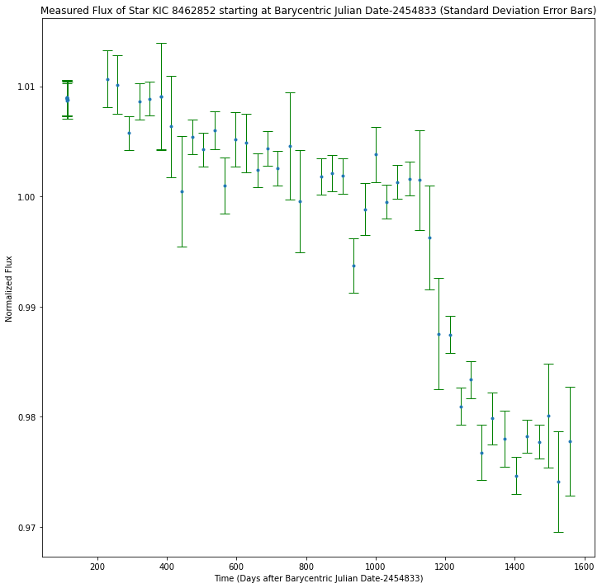

Graph of Dataset

With SEM Errorbars
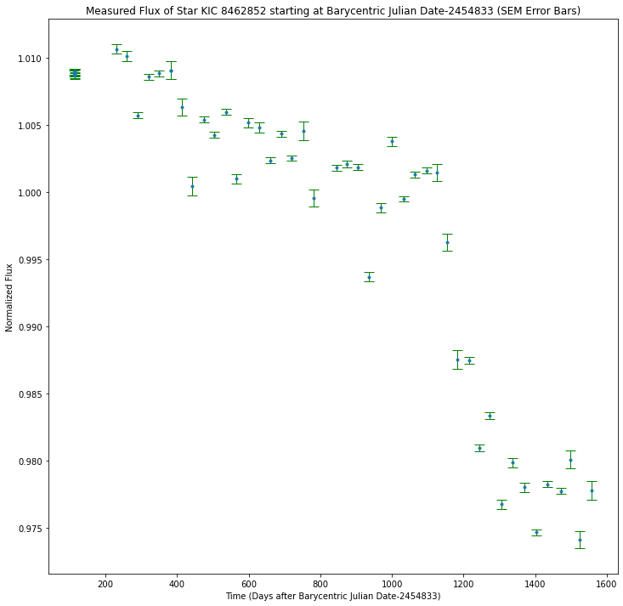

Histogram of Dataset

Using 6 bins
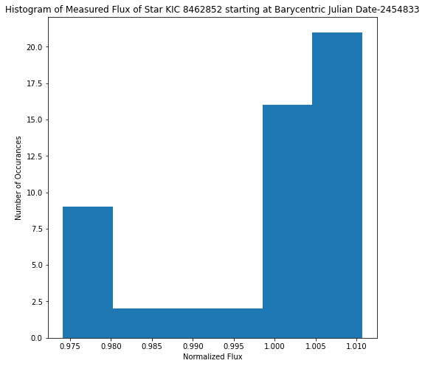

Explain reasoning for this :3

Firstly, I decided to use very little bins for the data to highlight the number of data points on either side of the normalized mean.

Addressing Possible Errors in Data

Determining whether the orientation of the telescope had a significant effect on the data
Part of the dataset lists the orientation that the camera was in when collecting that particular image. Montet, et al. (2017), explains that the Kepler space telescope had to rotate its orientation every 93 days to reposition its heat shield as it orbited the Sun. Therefore, there may be a discrepancy when comparing data between different orientations in the dataset.
To test this, I shall separate the data by orientation and plot the data separately to see whether each orientation is statistically similar when independent of each other.
The data with orientation = 0:
[1.01067 1.01014 1.001 1.0052 1.00485 0.99371 0.99885 1.0038 0.97677
0.97986 0.97803]

The data with orientation = 1:
[1.00574 1.00861 1.00887 1.00238 1.00437 1.00255 0.99951 1.00132 1.00162
0.97467 0.97825 0.97775]

The data with orientation = 2:
[1.00908 1.00909 1.00636 1.00044 1.00458 0.99956 1.0015 0.99628 0.98754
0.9801 0.97411 0.9778 ]

The data with orientation = 3:
[1.00896 1.00886 1.0089 1.00867 1.00898 1.00888 1.00895 1.00873 1.00541
1.00427 1.006 1.00183 1.00211 1.00186 0.98748 0.98096 0.98337]
To gain a bit of insight into whether the orientation had a significant effect on the data collection, I'll run a few Unpaired t-Tests. I chose Unpaired since the two datasets are not dependent on each other.
o0, o2
t Statistic: 0.2066843889101848 | p-Value: 0.8382471963090087

o1, o3
t Statistic: -1.3444862063825294 | p-Value: 0.18997868202057272

o0, o3
t Statistic: -1.430351365301097 | p-Value: 0.1645250264843329

o1, o2
t Statistic: 0.31290764612263294 | p-Value: 0.75729783124533

Since the p-value of these t-Tests do not go below 0.05, even for the most visually dissimilar data pairs, we conclude that the data show no statistically significant difference between each other. This also supports acceptance of the main null hypothesis that the flux is statistically similar (the same) throughout the dataset. We also conclude that the changing orientation of the Kepler space telescope had no statistically significant effect on the measurement of flux.

Plot of the data after separating by telescope orientation
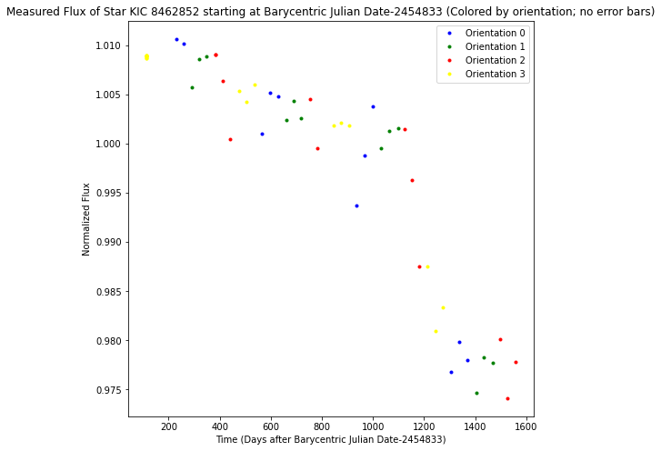
- Based on this data, we can rule out the possibility that a change in the telescope's orientation caused the sudden "drop" in flux that can be seen around 1200 days after BJD-2454833.
- This lines up with Montet et al. (2017), which explains that the orientation changes to realign the telescope's heat shield towards the Sun as it orbits.
- (If I'm being honest, I could've argued this without the colored plot if I had realized that the time was in days and not seconds like I had assumed at a glance... At least the data has a bit of color?)

Moments of the Data
Mean: 0.9984457692307693
Weighted Average: 0.9974869007540557
Variance: 0.00013334942056213018
Skew: -0.9502798625650863
Kurtosis: 2.388627204084122

Model Fitting

Creating a linear regression of the data

The following plot is for degree 7
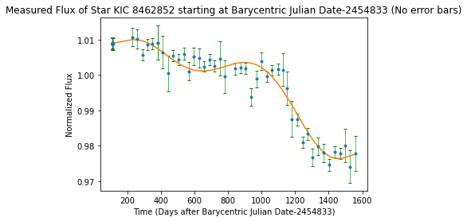
The R^2 score for this model is 0.9419203318750056

*******************************************************************************

The degree 8 polynomial parameters are [-2.50013360e-24 1.62908141e-20 -4.39189274e-17 6.36707000e-14
-5.40714215e-11 2.74176842e-08 -8.02902699e-06 1.19827028e-03
9.43977182e-01]

The model for this degree is
8 7 6 5 4
-2.5e-24 x + 1.629e-20 x - 4.392e-17 x + 6.367e-14 x - 5.407e-11 x
3 2
+ 2.742e-08 x - 8.029e-06 x + 0.001198 x + 0.944

The following plot is for degree 8
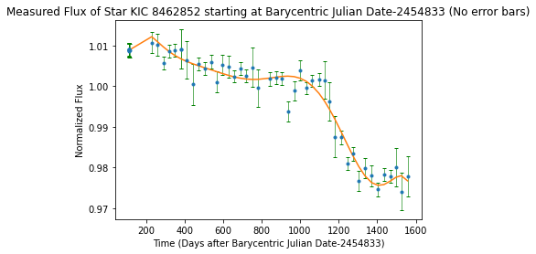
The R^2 score for this model is 0.9529021632102445

Degree 8 meets the R^2 requirement of at least 0.95 and is a suitable fit for the data.

Go with the 7th degree since the curve is no longer continuous after this.

First Data Analysis Test:

Moments of the Data Distribution

Second Data Analysis Test:

Normal Test
It's important to determine whether this data is normally distributed or not since this will determine the types of Hypothesis tests we can run on the data. This will also give better context for model fitting.
The data is confirmed NOT distributed normally with a p-value of 0.014418030476593782
The p-Value above give a decimal probability that the data is normally distributed. Since it is only a $1.4\%$ chance that it is, we can safely conclude that the data is **not** distributed normally with almost $99\%$ confidence.

Third Data Analysis Test:

One-Sample Wilcoxon Signed Rank Sum Test
The normal test leads us to the second data analysis test, a hypothesis test to determine whether the data is significantly different across the dataset.
We now know that:
- The data is non-parametric (not normally distributed)
- There is only one dataset being analyzed
- We need to compare each data point to a reference value in the dataset
Using the One-Sample Wilcoxon Signed Rank Sum Test, one can determine how significant the flux values differ from a reference value. For this, we will use the normalized mean of 11. This will help us determine whether the range of flux measurements is statistically different.
When performing this test, we will use a significance level of 𝛼=0.05α=0.05. This will give us a suitable 95%95% confidence level if our p-Value turns out higher than 0.950.95. The null and alternate hypotheses are the same as those stated in the introduction.
Rank: 645.5 | p-Value: 0.691992212761029
Since p-value > 0.05, we accept the null hypothesis; concluding there is probably no difference in the data. This will be especially likely if we draw the same conclusion from other tests.

Fourth Data Analysis Test:

Critical Value and P-Value Test
We will compare data at the far ends of the dataset to help determine if there is a significant difference in the data.
The easiest way to do this is to take the mean value of the data and compare it with the two test statistics at either end of the dataset.
I decided to try an exponential fit for this test since we already know that the data is not normally distributed. However, the data somewhat follows an exponential decay visually, so let's try it:
The critical z-score is: 3.6888794541139354

The z-score of the earliest data point, which is also one of the highest flux values, is: 6.565738930759811
The corresponding p-value is: 0.0028155666241611024
Therefore, we have a confidence level of: 0.997184433375839

The z-score of the latest data point, which is also one of the lowest flux values, is: 12.892501008313213
The corresponding p-value is: 5.0337071983440485e-06
Therefore, we have a confidence level of: 0.9999949662928016

